This Week in the Life & Work of our Church

KINCARDINE UNITED CHURCH
721 Princes St. N., Kincardine ON N2Z 2A3
Web site: www.kincardineunitedchurch.org
Youtube Channel: KUC YouTube Channel
Envelope Steward: kucesteward@bmts.com Gord’s email: gord.kuc@bmts.com
Office Coordinator’s e-mail: kuchurch@bmts.com Phone: 519-396-2391

The Congregation of Kincardine United Church seeks to foster a journey
of spiritual growth through hospitality, service, fellowship and study,
and, in community, to build up the ministry of every person
and together experience God's abundant love and grace.

WALK FOR ALZHEIMER’S 2020
On May 31st, 2020 The IG Wealth Management Walk for Alzheimer's is happening at home this year. People can "come together" in support of more than 1,000 local families living with dementia in Grey Bruce.

All funds remain in Grey and Bruce to help fund vital programs - like making life a little easier during Covid-19. The Alzheimer Society Grey-Bruce continues to run online support groups, one-to-one phone counselling, education workshops, Minds in Motion groups, and is sending out active living kits to those in need. A new website: www.ActiveLivingGreyBruce.org has been created to help those isolating at home find meaningful and engaging activities.

To sponsor a Team or Participant or be a Walker go to the Grey Bruce IG Wealth Management Walk for Alzheimer’s website:
https://alzheimer.ca/en/greybruce/Get-involved/Be-a-fundraiser/Walk-for-Alzheimers.

Kincardine is under the HANOVER umbrella. Click on HANOVER to get to their web page

Team Name: Kincardine Sunset Walkers

Note: To go to the Hanover webpage directly use:
http://www.alzgiving.ca/site/TR/WFA/WFA_ON_Grey-Bruce?pg=entry&fr_id=3002

For information call Lee Cox 519-396-7228

LET’S CELEBRATE KINCARDINE UNITED CHURCH
What an amazing family of faith we continue to become! During this pandemic each of us is connecting in new and creative ways. As a result, our ministry is thriving, reaching out into the community to continue to make a difference to many during our isolation. To celebrate the many ways our congregation vibrantly answers God’s call to love one another, let’s give a special gift financially to the church. Mark your special gift as “Gord’s Haircut.” Why? Because if over $2,000.00 is raised by our 169th anniversary Sunday on June 14th, Gord will shave all the hair from his head – trimmed and then with a safety razor.
Gord will record his transformation and you can find it on our new KUC YouTube Channel that evening. So, to donate that extra, you can click the “Donate” button on our website at www.kincardineunitedchurch.org, you can contact our Envelope Steward, John Philips, at kucesteward@bmts.com to increase your PAR or you can mail in a cheque to the church at 721 Princes Street, Kincardine, ON. N2Z 2A3. How ever you choose to celebrate the ministry of our faith community, we are so blessed.

PROGRAMME CALENDAR

SUNDAY, June 7th Trinity Sunday, Communion (served digitally)
Worship: Gord Dunbar
Meditation: Weaving a Whole

SUNDAY, June 14th 2nd Sunday after Pentecost
Worship: Gord Dunbar
Meditation: Called Out

SUNDAY, June 21st 3rd Sunday after Pentecost, Father’s Day
Worship: Gord Dunbar
Meditation: COVID from the Front Lines

SUNDAY, June 28th 4th Sunday after Pentecost
Worship: Gord Dunbar
Meditation: Let’s Get Creative!

Services live streamed on Sundays at 10:30 a.m.
Email kuchurch@bmts.com to get on the email list and receive live stream invitations.

Recent services can be found on our Youtube Channel: KUC YouTube Channel

Services will continue to air on Rogers Cable Channel 6 a week later.
View the schedule here: https://www.rogerstv.com/schedule?lid=1&rid=75

You can view some past services online at https://www.rogerstv.com/media?lid=237&rid=75 under Access Programming
(no cable tv necessary)

MEALS ON WHEELS IS EXPANDING DURING THE PANDEMIC
For members in our community experiencing financial constraints, are mobility challenged and/or are in extreme isolation during the current pandemic.
Municipality of Kincardine community members in need are being identified by service contact persons through word of mouth, web or social media pages and as existing clients prior to the pandemic.
Residents that would like to inquire about Meals on Wheels for themselves or a loved one can visit the Grey Bruce Home and Community Support Service (HCSS) Website at https://hcssgreybruce.com/meals-on-wheels/ or call their Central Intake number at 519-372-2091 Press 1.

MISSION AND SERVICE COMMITMENTS IN THIS TIME OF COVID-19
Kincardine United Church is a leader in giving generously to Mission and Service. Mission and Service makes commitments on behalf of the United Church of Canada to partners across Canada and internationally. Those commitments provide the foundation for the budgets of the partners with which we work. Please continue offering your generous gifts to Mission and Service – which is the way we reach out to an aching world to make a difference – so that our partners can continue caring for people in the name of Christ. Thank you.

#HereToHelpGB
A new grassroots campaign launched by the following partners: 211 Central East Ontario, the Owen Sound Police Service, Saugeen Shores Police Service, West Grey Police Service, Hanover Police Service, Ontario Provincial Police, Canadian Mental Health Association Grey Bruce Mental Health and Addiction Services, Bruce Grey Child and Family Services, Women’s House Serving Bruce and Grey and The Women’s Centre Grey Bruce.

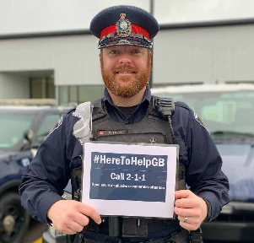
This campaign has been created to reach kids, youth and women who are in abusive situations or feeling scared during this time of isolation. With recent closure of so many public and institutional settings, the caring eyes & ears that usually provide comfort and act as safeguards are not physically present. The goal of the campaign is to let individuals who are in need of support know they are not alone and help is available.

Please help spread the message that we are #HereToHelpGB.

Numbers for help:
- 2-1-1 is a 24/7 multilingual helpline to find services in your community
- 9-1-1 is for all emergency situations
- 226-974-0755 is a text support line for women in crisis
- 1-800-668-6868 is Kid’s Help Phone
DONATIONS
During these difficult times, making donations to the church is severely hampered!
We have added E-Transfers as a “New” donation method and instructions are now available on our church web site http://www.kincardineunitedchurch.org
E-Transfer:
- From the web-site additional instructions will guide you through the new process using your bank software!
- With E-Transfer you can make a contribution directly from your bank account to the church bank account.
- The church receives the full amount as there are “no” fees on our end, unlike many other donation methods that charge us a service fee.
PayPal:
- The second option is PayPal. From the website, a pop-up will link to the secure PayPal web site, where you can use your PayPal account or use your credit card.
These contributions will be administered by the Envelope Steward and get added to your yearly contribution totals. Please provide donor contact info as needed.

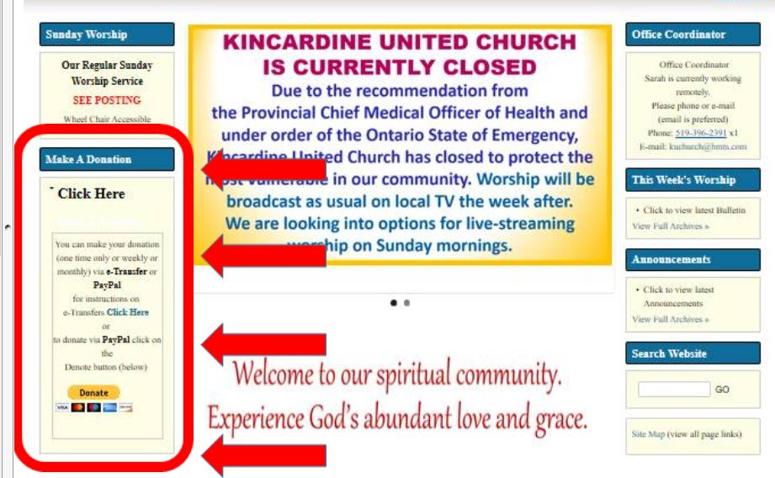

COVID-19
We are CLOSED until further notice, following the orders from Premier Doug Ford and the recommendations of the Provincial Chief Medical Officer of Health.

The Council of Kincardine United Church will continuously monitor the evolving circumstances around COVID-19, keeping the congregation informed regularly about any changes to our practices. Our highest priority is for the safety of everyone – staff, volunteers, congregants and the public – especially the most vulnerable among us.

- Worship will be broadcast as usual on local TV the week after.
- We are live-streaming worship on Sunday mornings.
- Gord’s reflections will continue to be sent out with links to the bulletin & any announcements
- Please contact the church office by phone or by e-mail (email is preferred – kuchurch@bmts.com.

As a family of faith, many of us rely upon one another for mutual support and for companionship. The Membership and Mission Committee has put into place remote ways of pastoral care. May God bless us as we love one another from a distance.
If you wish to be added to this contact list email Melinda Smegal at glorycangel@yahoo.ca

ANNOUNCEMENT INFORMATION DEADLINE

Submit information to kuchurch@bmts.com by 4 PM on TUESDAYS

Thank you.

Even during COVID-19, Emergency Departments are operating as usual. It is okay to go to the ER. If you or a loved one are suffering from symptoms of a stroke, heart attack, or other new serious health issues, do not delay. Call 9-1-1 or go to the nearest emergency department for assessment right away. 🏥 🚑

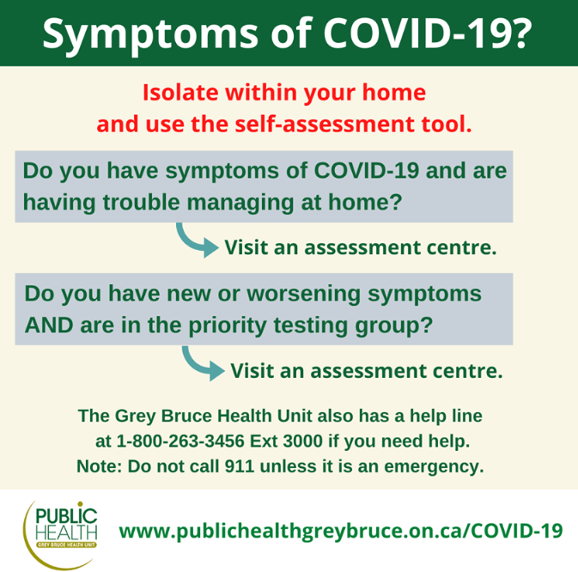

https://covid-19.ontario.ca/self-assessment/

Link to Grey-Bruce Assessment Centre List

Link to Priority Testing Details

www.publichealthgreybruce.on.ca/covid-19

COVID-19 and MENTAL HEALTH

NEW “Apart But Not Alone”
Offered by CAMH (Centre for Addiction and Mental Health)
https://action.camh.ca/apart-not-alone

Sign up to learn concrete ways to manage your stress and uncertainty during this difficult time — and receive regular support and encouragement right in your inbox
along the way.

Anxious and stressed out? Help is at hand!
Check out the new Wellness Together Canada portal which provides free online courses like Taking Control of Stress and resources like Moving Beyond Anxiety. https://ca.portal.gs/

More Resources: If you or someone you know is feeling overwhelmed or in crisis, there are supports available. Canadian Mental Health Association of Grey Bruce has lots of information on their social media sites and website at http://cmhagb.org/

Mental Health Crisis Line of Grey & Bruce (24 hours) For ages 16+ Phone: 1-877-470-5200

Grey Bruce Health Services Crisis Team (24 hours) Phone: 519-376-2121 (Ask for Crisis Team)

Kids Help Phone is a free, anonymous and confidential phone and on-line professional counselling service for children and youth. Big or small concerns! Open 24/7 365 days/yr.
Website: www.kidshelpphone.ca – for on-line chat as well as resources and information
Phone: 1-800-668-6868 By Text – Text “TALK” to 686868
Download the “Always There” app to Chat

*************************************************************************************************************Information below is taken from https://www.heretohelp.bc.ca/infosheet/covid-19-and-anxiety.

Anxiety is a normal reaction to uncertainty and things that may harm us. For many of us, the coronavirus and the COVID-19 illness make for a very uncertain future.
Take action … Taking reasonable action can help you take back control and reduce anxiety. Look to trusted organizations and agencies like the Government of Canada, and World Health Organization for information about steps you can take to reduce your risk of getting sick or passing the illness on to others.

- Government of Canada—www.canada.ca/coronavirus and the COVID-19 Information Line at 1-833-784-4397
- World Health Organization—www.who.int/health-topics/coronavirus
- Ontario Public Health
- Fact Sheets: How to self-monitor - COVID-19, How to self-isolate - COVID-19
Cleaning and Disinfection for Public Settings - COVID-19
Self-isolation: Guide for caregivers, household members and close contacts
- COVID-19

Explore self-management strategies
Explore self-management strategies like mindfulness, yoga, meditation, art, or exercise to manage anxious thoughts. You can find self-management strategies for anxiety from Anxiety Canada at www.anxietycanada.com. You can also take the Bounce Back Online, a self-directed course from the Canadian Mental Health Association to help people manage low mood, stress, and anxiety. The online version is free, no referral needed. Visit online.bouncebackonline.ca.

MINUTE FOR MISSIONS MAY 31, 2020

OUR GENERATION

At Toronto Conference’s annual meeting in 2011, youth delegates presented a vision for the future of their church and their place in it. The result of those first ideas was a song that has since inspired many people. Thanks to a Mission & Service Vision Fund grant, the group was able to record it, and that amazing and inspirational song—“Our Generation”—has become the theme song for the Mission & Service music video.

Seven youth delegates came together one Friday evening to practise their instruments and vocals for a Saturday recording session at Black Earth Music’s Area 51 recording studio in Shelburne, Ontario. When they arrived at the studio the nervous excitement was thick in the air, especially when they were introduced to their producer, Michael Jack, who has produced records for Rush and Pink Floyd. But as the recording sessions went on, thanks to Michael’s encouragement, the group became more confident in the process, creating space for the creativity of voices and instruments to become part of the song. The group supported and encouraged each other to experiment vocally and add guitar riffs.

If Mission & Service giving is already a regular part of your life, thank you so much! If you have not given, please join me in making Mission & Service giving a regular part of your life of faith. Loving our neighbour is at the heart of our Mission & Service.

