This Week in the Life & Work of our Church

KINCARDINE UNITED CHURCH
721 Princes St. N., Kincardine ON N2Z 2A3

The congregation of Kincardine United Church strives to be a loving, hopeful
and inclusive community of faith that nurtures Christian discipleship.
Link to Sunday 11:00 a.m. Zoom Service: https://us02web.zoom.us/j/84938054100
Passcode: 3962391
Office Coordinator’s email: kuchurch@bmts.com  Office phone: 519-396-2391
Office Hours: 1:30 – 5 p.m. Tuesday through Friday
Gord’s email: gord.kuc@bmts.com  Gord’s cell (for pastoral emergencies): 519-386-6346
Donation Steward: kucdonate@bmts.com Web site: www.kincardineunitedchurch.org
YouTube: KUC YouTube Channel Facebook: KUC Facebook Page

A/V NEEDS YOU!
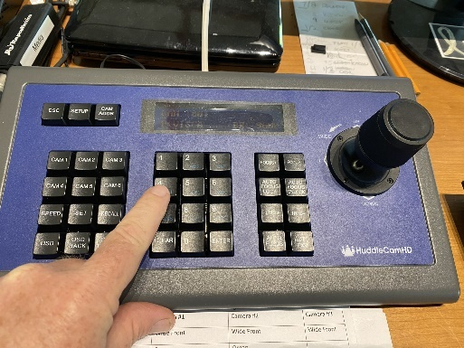
If you can help us continue to provide some of our A/V during church services, please contact John Phillips, Judy Zarubick or contact the church office.
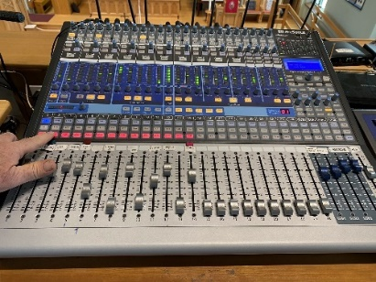
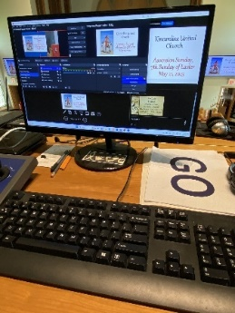

WEEKLY DEADLINE FOR ANNOUNCEMENT INFORMATION
Submit information to kuchurch@bmts.com by 4 PM on TUESDAY.

PROGRAMME CALENDAR
(services are both in-person and live streamed)

SUNDAY, July 2 11:00 AM Celtic Service
Worship: Gord Dunbar
Meditation: Listening for Love

Services air on Rogers Cable Channel 6 a week later and repeats at various times thereafter. View the schedule here: https://www.rogerstv.com/schedule?lid=1&rid=75
You can view some past services online at https://www.rogerstv.com/media? lid=237&rid=75 under Access Programming (no cable tv necessary)

Electronic payment methods available on our website. Mark your donation “Broken Windows”

