FIRE IN THE BELLY DURING WINDS OF CHANGE

This Sunday we celebrate the Feast of Pentecost. It is the story in Acts chapter two where the gift of the Holy Spirit is received by the disciples, perceived as flames of fire and the sound of a mighty wind. At this point the disciples were still isolated in the Upper Room in Jerusalem. This is the room in which Jesus washed their feet as their slave and shared the last supper with them on the Feast of the Passover. Through that shared meal, Jesus reframed their understanding of liberation from oppression in light of his sacrificial self-giving on the cross. At the time they didn’t fully comprehend the meaning of what we now call the sacrament of communion.

Later that night, after praying in the Garden of Gethsemane, Jesus was arrested, beaten, humiliated, tried, flogged and crucified. Filled with fear and dread that they would share Jesus’ fate if they showed their faces in the crowded city, the disciples huddled in the Upper Room. Even after Jesus’ resurrection, even after he showed them his scars and blessed them, even with their joyful hope restored, they remained isolated in the Upper Room, still afraid to venture back into the world.

We, too, are isolated, staying at home and restricting our own freedom of movement so as to protect others. The church building is closed so that we cannot gather for worship. In some ways it may seem we are even more isolated that the disciples, huddling at home, waiting for that “maybe” time when things will return to “normal.” However, though the church building is closed, the church – our family of faith – is alive.

On the Feast of Pentecost, the gift of the Holy Spirit soaked so deeply into the souls of the disciples that they could no longer huddle in fear in that Upper Room. Instead, to their surprise and risky delight, they ran into the streets to proclaim the good news of Jesus’ resurrection. They did so with such fire in their bellies that everyone – regardless of their ethnic or national identity – understood them. The good news the disciples were proclaiming was that the winds of change were blowing at gale force. Those winds were whipping the weathervane of purpose from power over others through oppression to power with one another through self-giving love.

That same Pentecost gale is blowing now. We are at a tipping point. This pandemic has forced us all to huddle for a time at home, giving us time to consider what the pandemic is teaching us. Will we bide our time so we can return to the way we have “always” done things as a church? Will we rush into the streets to share the good news filled with fire in our belly? Will we keep the best of what we used to do as a church while catching the Spirit’s wind of change in our sails for the voyage ahead?

WE CAN VERSES WE CAN’T
During this tipping point, do we choose to believe we can embrace the possible? As Henry Ford once said, “Whether you believe you can or believe you can’t, you’re right.” We need to believe in our call to make a difference in the world. We are a growing church according to an article in the latest Broadview Magazine. Growing churches find a way forward within change, taking the time to discern how and to experiment with what. That way forward as the Spirit wind catches our sails follows the Way of Jesus as we are sent out into the community and the world.

THEM VERSES US
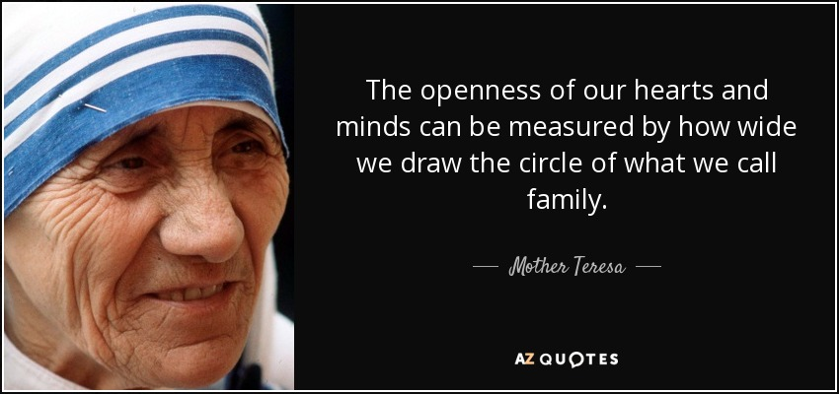
As much as I try to listen carefully to feedback from the people in our family of faith, growing churches focus on the people they are trying to reach. It seems counter-intuitive, but our mission is not to look after ourselves like some exclusive club. Instead, God calls us, providing the Spirit as our strength and our inspiration, so we can create a space and an experience for those who are not yet part of our circle of loving kindness and of risky mission. That’s why we need the fire in our belly the Spirit provides. This is our own Pentecost experience.

PRINCIPLES VERSES PREFERENCES
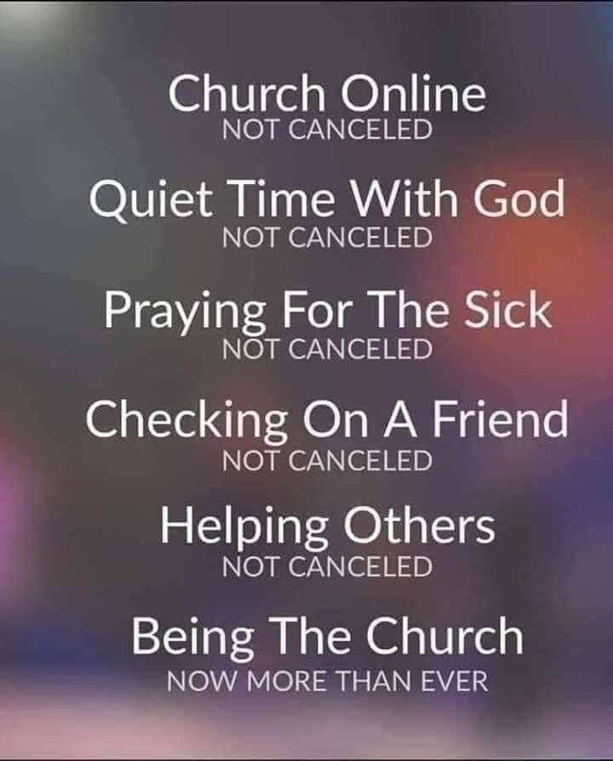
One of the biggest challenges in any congregation is balancing the expressed desires of everyone – balancing the differing theological perspectives, balancing the musical preferences, balancing the governance preferences for structure and policies, balancing the conflicting preferences for interior and exterior design, balancing the staff compliment for differing priorities. However, growing churches focus on the mission to which Jesus calls us. While we should not ignore the needs of our members, we must realise that the needs or our members are best filled by making our lives about something bigger than our preferences. In what principles will we root our mission?

PROACTIVE VERSES REACTIVE
We closed our church building and asked the staff to work from home. That was an appropriate reaction to the pandemic and the orders to close from the provincial government. However, during this time of learning and of discernment, we need to become proactive. This means that we prayerfully discern what actions we need to take on the issues that will have an impact on our future as people following the Way of Jesus. After all, if we never get around to charting a course for the future, we will have no future. Let us this summer, then, take the time to discern how to lean proactively into the winds of change that will enable our family of faith to continue to thrive with vitality and with purpose.

TODAY VERSES SOMEDAY
In our reaction to this pandemic, we have already acted. We acted immediately because we were forced to do so. However, there is a danger that we become complacent in our new reality. I deeply appreciate the almost daily feedback I am getting from many in our congregation, suggesting possible ways we can act to continue to improve what we are doing and to experiment with what we might be able to do. There is a creative energy that feels to me like Pentecost’s fire in the belly. People are stepping forward to volunteer, taking on some of these initiatives, enlivened by the challenges we are facing because of the possibilities of who we continue to become. We need to build on that enthusiasm (the word “enthusiasm” comes from the root words for inspired or possessed by God – just like the gift of the Spirit at Pentecost. To build on this enthusiasm, this summer we will have a series of small Zoom enabled groups to discern how we will catch the winds of change in the sails of our mission. It will begin happening near the end of next month – which is pretty swiftly for us compared to past practice. That, too, is the change I believe we are being called to embrace.

Thanks be to the Spirit for the inspiration. Thanks be to God for the courage. Thanks be to God for the will. Thanks be to Christ for the Way.

Kincardine United Church has grown by the measure of worship attendance by 15% over the past five years: https://broadview.org/united-church-growth/

